**NLP PHASE 2: INNOVATION IN FAKE NEWS DETECTION:**

In this stage, we use cutting-edge Natural Language Processing (NLP) methods to improve our false news detection system. Our innovation approach prioritizes incorporating deep learning models like LSTM and BERT.

**PRECISE LEARNING:**

Artificial neural networks with numerous layers are used in Deep Learning, a potent branch of machine learning, to extract complex features from input. This structure comprises a final output layer, one or more hidden layers, and an input layer. The network's individual neurons each process information from the layer before them, allowing the model to learn intricate patterns and representations.

**INNOVATION:**

As part of our innovation phase, we integrate cutting-edge methodologies to improve the current machine-learning model.

On improving the efficacy of fake news detection

Making use of Deep Learning Models

We will investigate deep learning models like LSTM (Long Short-Term Memory) networks in place of conventional ML algorithms. LSTM is a good choice for text classification jobs since it is excellent at capturing long-term dependencies in text. It can pick up on word representations in context, which are essential for spotting false news.

Leverage Pre-trained Language Models

For feature extraction, we will make use of pre-trained language models like BERT (Bidirectional Encoder Representations from Transformers). BERT delivers a profound comprehension of language because it has been extensively trained on text data. We can improve the features utilized for training downstream models like LSTM, improving their comprehension of the text, by extracting contextualized word embeddings from BERT.

Apply Transfer Learning: We will execute transfer learning by adjusting a previously trained model.

BERT model for the purpose of identifying bogus news. This entails building a classifier layer and then using our dataset to train only the new layers. As BERT has previously gathered knowledge from a sizable text corpus, this method enables us to obtain spectacular outcomes with less data.

**STEP-BY-STEP GUIDELINES FOR INCLUDING DEEP LEARNING MODELS:**

The stages involved in our implementation are as follows:

1. Bring in models from BERT and Keras.

2. Data preparation.

3.build BERT embeddings.

4. A deep learning model should be built.

5. Use BERT to implement transfer learning.

6. Build the model and then train it.

7. The deep learning model should be evaluated.

8. Improve the dataset and model over time for improved performance.

9. Save the trained model if you want to use it later.

10. To produce predictions based on fresh data, use the model.

**MODEL DELIVERY:**

Once our false news detection model is as effective as possible, We can make it available to more people by deploying deep learning techniques:

Deployment to Web or Application: We suggest creating a user-friendly web interface for the model using tools like HTML, CSS, and JavaScript to make it accessible to end users.

Real-time Monitoring (Innovation): For ongoing development, think of incorporating the model into a platform that can scan and categorize news stories as they are posted online in real time.

**SELECTION OF TECHNOLOGY:**

LSTM is an appropriate deep-learning model for this project if the dataset is going to remain small and interoperability is important.

**CONTROL DIAGRAM (LSTM , BERT):**

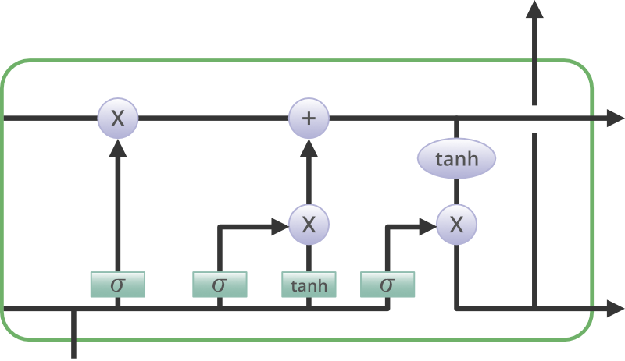

***STRUCTURE OF LSTM***

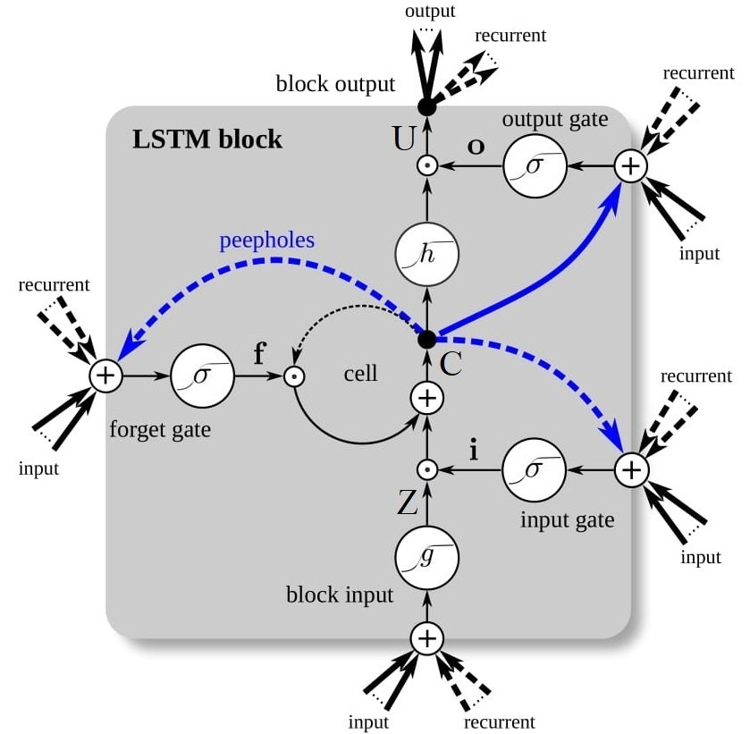

***LSTM ARCHITECTURE***

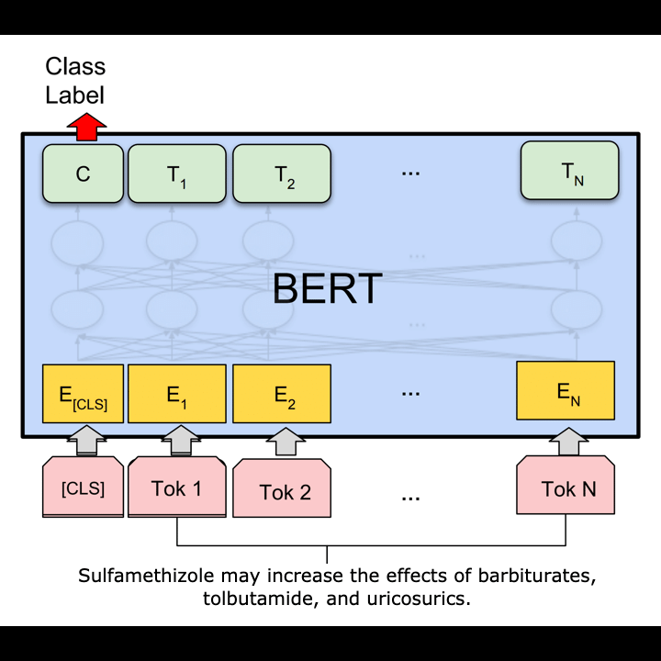

***BERT ARCHITECTURE***